caBIG®
Clinical Information Suite

Component Test Plan

Author : Brian Bell
Ekagra Software Technologies, Ltd
Team : Quality Assurance
Subcontract : 29XS223STO3

Document Change History
Version Number | Date | Contributor | Description
V0.1 | 3/25/2010 | Brian Bell | Initial outline
V0.3 | 4/07/2010 | Kevin Gann | Added Referral test cases
V0.4 | 4/09/2010 | Brian Bell | Input from Amrut and finalize for I1S2
V0.5 | 4/12/2010 | Brian Bell | Separate docs for Test Cases
V0.6 | 4/19/2010 | Brian Bell | Updates from review session
V0.7 | 4/19/2010 | Brian Bell | Updates for the end of R1-I3S2
V0.8 | 6/29/2010 | Brian Bell | Updates from SAIC-F review
V0.9 | 8/10/2010 | Brian Bell | Added Operations & updated HP QC
V1.0 | 9/14/2010 | Brian Bell | Name and project changes
V1.1 | 10/26/2010 | Aviva Mordetsky | Updated SVN URL changes
V1.2 | 12/30/2010 | Brian Bell | Demo Pilot scope and UI test process


Updated December 29, 2010
Table of Contents

1 Introduction 2
1.1 Component Testing Approach 2
1.2 Relationship to Other Documents/Plans 2
1.3 Scope 2
1.3.1 In Scope 2
1.3.2 Out of Scope 3
1.4 Roles and Responsibilities 3
1.4.1 Development DSL/Stream 3
1.4.2 QA DSL/Stream 3
1.4.3 Architecture DSL/Stream 3
1.4.4 Requirements DSL/Stream 3
1.4.5 Continuous Delivery Operations (CDO) Stream 3
1.5 Assumptions 3
1.6 Constraints 4
2 Component to be Tested 4
2.1 Component Operations 4
2.1.1 Referral Component Operations 4
2.2 Architecture Artifacts for Test Case Preparation 5
2.2.1 Review the PIM 5
2.2.2 Review Design Model 5
2.2.3 Check ISO 21090 HealthCare Datatypes 5
2.2.4 Check the Terminology Worksheet for Data Values 6
2.2.5 Web Services Definition Language (WSDL) File 6
2.3 Test Case Creation Process 6
2.3.1 Test Case Planning 6
2.3.2 XML Test Script Creation 7
3 ISO 21090 Datatype 9
4 Automated Test Tools 9
4.1 Automated Testing 9
4.2 Requirements Traceability 10
4.3 Metrics and Defect Tracking 10
Appendix A – Example HP QC Component Test Report 11

Introduction
This Component Test document describes the methods, tools and components component-level Quality Assurance aspects of the caBIG® Clinical Information Suite project.

Component Testing Approach

Component Testing refers to the functional testing of each webservice independently to assure that it meets the requirements, adheres to the design specification and provides the correct expected results when exercised using set of test cases that test all of the requirements.

caBIG® Clinical Information Suite uses a Continuous Integration, or Continuous Delivery, approach to development and testing. Test automation will be used to the greatest extent possible. The goal is to automate all test cases within an iteration so that the subsequent iteration will have a 100% automated regression test suite. Test cases will be clearly documented so that they can be executed either manually or automatically.

Relationship to Other Documents/Plans
Component testing is the second in the series of: unit, component, system, regression, integration, performance and deployment testing required for verification of the caBIG® Clinical Information Suite system.

The caBIG® Clinical Information Suite Master QA Plan describes testing terminology definitions and overall scope and approach to Quality Assurance on the project.

Directly related to this document:
- Unit tests are fast running tests that typically test individual classes that don’t have heavy external dependencies like databases. Unit tests are exclusively created and executed by the Development team.
- Component tests are focused on web services, generally verify more than one class and, typically, rely on external dependencies such as a database. Component Testing is performed by the QA team.

Scope

In Scope
The Component Test scope includes the following:
- Testing of functional requirements on a component by component basis
- Limited testing of non-functional requirements (performance, scalability, security etc.), where applicable at the component level.
For the Demonstration Pilot, validation will be done via web browser to include:
- Customized screens created by ESD
  - Diagnosis Screen
- Outcomes Export functionality
- Regimen Finder Functionality

Out of Scope
The following are considered out of scope for caBIG® Clinical Information Suite Component Testing:
- Complete testing of all non-functional requirements (performance, scalability, security etc.)
- End-to-end testing and testing of interfaces of all systems that interact with the caBIG® Clinical Information Suite.
- Out-Of-The-Box Tolven functionality for Demonstration Pilot

Roles and Responsibilities
The following teams have roles associated with component testing:

Development DSL/Stream
Responsible for:
- Develop the system/application
- Conduct Unit, system, regression and integration testing

QA DSL/Stream
Responsible for:
- Develop the Component Test Plan
- Develop test cases
- Conduct Component, system, regression, performance, deployment testing

Architecture DSL/Stream
Responsible for:
- SAD
- CFSS, PIM
- Non-functional requirements

Requirements DSL/Stream
Responsible for:
- Develop Use cases and requirements in collaboration with the Adopters. This forms the basis for test case development.

Continuous Delivery Operations (CDO) Stream
Responsible for:
- Support of the Continuous Delivery environment

Assumptions

- Requirements baseline has been established for a given cycle (sprint/iteration/release).
- Architecture baseline has been established for a given cycle (sprint/iteration/release).
- For software to pass Test Readiness Review (TRR) milestone, the Developer team has completed unit, system and integration testing and met the entire baseline Requirements for that cycle.
- Test scripts are developed, reviewed and approved.

Constraints
- QA team must work from a baseline set of artifacts.
- Test scripts must be approved by Test Lead prior test execution

Component to be Tested
This section lists the component operations to be tested and the process to plan, define, record, and execute component test cases.

For each operation:
- Set the pre-conditions of the object definitions
- Execute the operation
- Verify the post-conditions of the objects.
Component tests will be divided into the following categories:
- Valid Value tests
- Invalid Value tests
- Cardinality tests
- Does Not Exist tests
- Null Value tests
- Multiple Value tests
Not all of these test categories are valid for all XML elements/attributes.

A test case template is located in a separate document “Component_Test_Case_Template- caEHR.doc” in the subversion repository:
http://caehrorg.jira.com/svn/CACIS/trunk/documents/QA/Test_Cases/
The test case template will be used to create test cases for each of the components.

As noted in Section 4, HP Quality Center is used for test case management and reporting.

Since no testable webservice is being delivered with Demonstration Pilot, no component testing will be executed. Only GUI based testing will be done.

Component Operations
Operations currently under development and/or available for testing:

Referral Component Operations
- createReferralOrder
- reviseReferralOrder
- withdrawReferralOrder
- queryReferralResult
- queryReferralOrder
- queryReferralOrderStatus
- acceptReferralOrder
- rejectReferralOrder
- queryClinicalDocuments

Provider Registry Component Operations
- findProviderByExample

Demo Pilot Component Operations
- findRegimenByExample
- extractOutcomesInformation

This sub-section is up-to-date as of December 29, 2010. It will be updated as the project progresses in the development of component operations.

Architecture Artifacts for Test Case Preparation

The following summary steps are recommended for creating test cases and their associated XML payloads:
- Review the Platform Independent Model and Service Specification (PIM) document
- Review the design model
- Check data type details in the ISO 21090 HealthCare Datatypes Standard
- Check the Terminology Worksheet for data values

Review the PIM
The PIM is delivered by the Architecture Team and is located at:
http://caehrorg.jira.com/svn/CACIS/tags/ReleaseCycle2/Iteration2/Architect/Specifications/

Review Design Model
Enterprise Architect is the caBIG® Clinical Information Suite standard modeling tool, however, to enable teams downstream from the Architecture team to interpret the model with less architectural expertise a series of informational artifacts are produced by the Architecture team in each iteration.

The RMIM (Refined Message Information Model) is the normative representation (i.e. it is the definitive specification model). The RMIM is created in Visio with a specific HL7 Visio plug-in. For caBIG® Clinical Information Suite teams downstream from the architecture team the RMIM generated documents will be used to interpret the specification. Specifically these documents are, in order of importance:
- Visio JPEGs
- Terminology Worksheet (Excel)
- ExcelFiles
- TableViews (html)
- BusinessHTML
The JPEG images are located at:
http://caehrorg.jira.com/svn/CACIS/tags/ReleaseCycle2/Iteration2/Architect/Models/Informational/model-jpgs/

Check ISO 21090 HealthCare Datatypes
See the ISO standard document for understanding the data types and enumeration (list of values) for common data elements. The ISO standards document and other NCI information on ISO 21090 is located here: http://docs.google.com/fileview?id=0B4kfacwnGiBlZmNhYjc1ZTAtMTc1NS00OWNmLThmNTgtMmJiNzdiODM1NTIw&hl=en

Check the Terminology Worksheet for Data Values
The Terminology Worksheet lists each of the Concept Domains and Value Sets used in the Information Models and Datatypes. It includes formal and business names, descriptions, rationale and usage notes. The worksheet helps reviewers quickly review, understand and navigate the vocabulary artifacts used by the in-scope domain areas. It provides high-level information for mapping and, also identifies relationships between vocabulary artifacts. The Terminology Worksheet is located here:
http://caehrorg.jira.com/svn/CACIS/tags/ReleaseCycle2/Iteration2/Architect/Specifications/

Web Services Definition Language (WSDL) File
For each service the Architecture Team will deliver a WSDL file from which test case XML can be derived. For example the R1-I2S2 WSDL file is located here:
http://caehrorg.jira.com/svn/CACIS/tags/ReleaseCycle2/Iteration2/Architect/Models/Informational/Schemas/

Test Case Creation Process

Test Case Planning
Based on the architecture artifacts described in the previous section component test cases are developed for each operation. Using the HL7 generated “ExcelFiles” artifact (see sub-section 2.2.2) QA test engineers will create test case scenarios to outline the test cases required for an operation. An example of a test case scenario definition appears below:

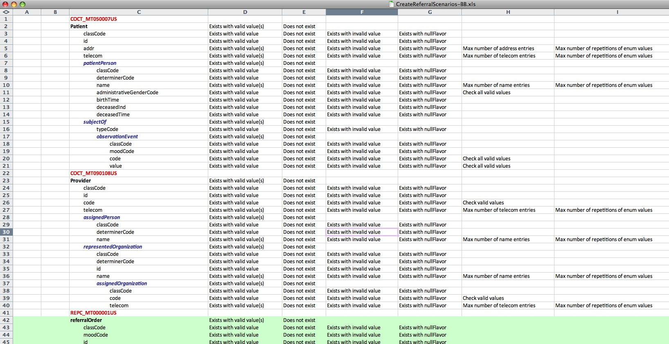

For each data attribute the following tests are identified, as applicable to the type of data:
- Attribute has a valid value
- Attribute has an invalid value
- Attribute does not exist
- Attribute has a null value (includes nullFlavor)
- Multiple values tests
  - The maximum number of repeated “enum” entries is tested
- Cardinality tests
  - The maximum number of attribute entries is tested

To aid in the creation of test cases exercising a variety of data values the following spreadsheet can be created based on searching the Architecture artifacts:

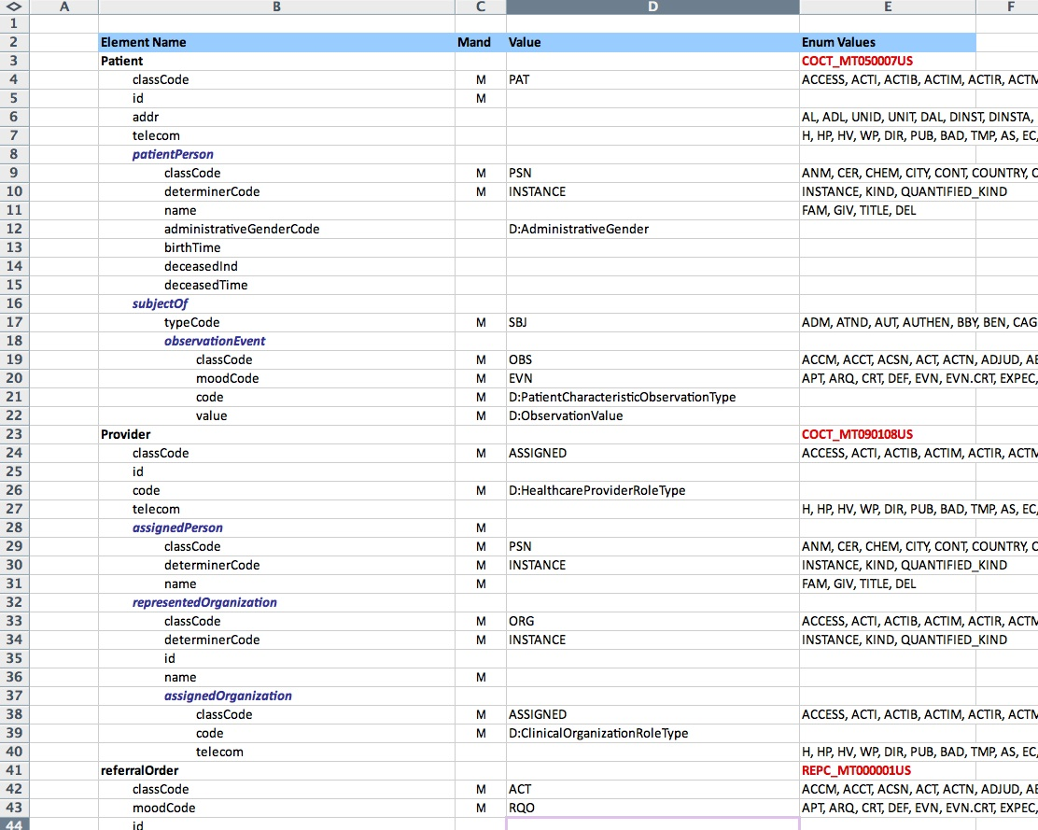

This HL7 derived artifact lists the values for each attribute, or identifies the Terminology Worksheet tab to be consulted to find the valid values.

Once test case scenarios are created, XML test scripts are developed and executed in SOAPUI. Examples of test case scenarios are located at:
http://spreadsheets.google.com/ccc?key=0AskpIrrhG15KdFlmNmJlUlpFSzFBYU9OTUt3UVJRZ2c&hl=en

XML Test Script Creation
Test scripts consisting of XML message payloads are developed based on the test scenarios as follows:
- In SOAP UI create a new project and associate the build WSDL with the project. Save it as a local project on your personal computer.
- In the “Test Properties” section of SOAP UI set the project to be a Composite Project (“true”). This saves each test case as a separate file.
- In the Project create a new “TestSuite”. Generally the team sets up one test suite per tester. For example, separate team members may test the Patient, Provider, Referral Order, and Treatment Plan parts of the createReferral service. Separate test suites would be created for each tester’s suite of tests.
- Under the TestSuite create a “TestCase” for each test to be performed. Name the TestCase by the Test Case ID (e.g. EHR-PAT-001).
- Double click the test case entry and, under the “Test Steps” tab, click the “Create a new Test Request TestStep” button. Name the test step by the Test Title given in the Test Scenarios spreadsheet.
- Copy a minimum XML message into the test step and tailor it as required to meet the test case requirements.
- Once all of the test cases are successfully created on the local computer, copy the test case files to the appropriate folder in the SVN directory and commit to the SVN repository. This will allow other members of the team to access each tester’s TestSuite.

The image below shows an example of test case EHR-RO-001 in the ReferralOrder test suite:

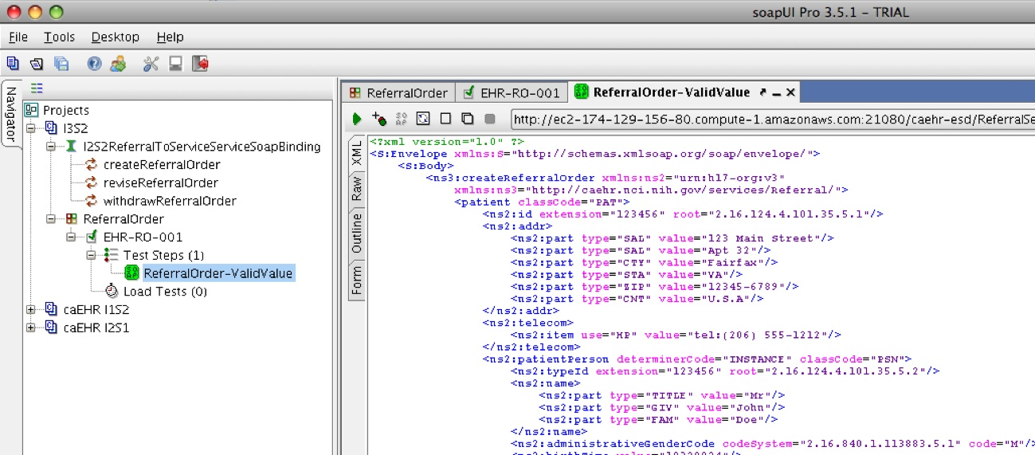

Demo Pilot User Interface Testing

For the Demonstration Pilot, validation will be done via a web browser to test a customized Diagnosis screen created by ESD. Initially, user interface testing will be performed manually. A tester will execute test cases by manually entering data into the browser as required by the application.
The Quick Test Professional (QTP) tool will be used to automate user interface testing once the volume of UI based component testing reaches a significant volume. Further details on the use of QTP will be added to this document once QTP is installed and configured with the caCIS project’s HP Quality Center testing environment.

ISO 21090 Datatype

At the beginning of the project the ISO 21090 NCI localization used was leveraged from previous NCI projects. The project plans to migrate to a full ISO 21090 implementation based on the following strategy:

Long-term: The timeline for the full implementations of the 21090 data types required by the caBIG® Clinical Information Suite project team is not yet determined, a fact that drives the necessity for both a Short-term and Mid-term strategy.
Short-term: The ESD team will expand the implementations of the current ISO 21090 caBIG® Clinical Information Suite data-types-of-interest by removing all constraints.
Mid-term: Depending on the when the Long-term strategy becomes usable by the full team, The OntoReason organization has agreed to make available for internal team use a RIM-compliant persistence layer with associated non-constrained implementations of all 21090 data types used by the persistence layer which OntoReason developed for proof-of-concept usage at MD Anderson. There are no IP issues associated with the project team's use of this persistence layer and associated 21090 implementations. In addition, because the technology was developed for a caBIG cancer center, the relevance to the data type requirements of the caBIG® Clinical Information Suite team appears to be high.

Automated Test Tools
In this section we provide an overview of the key tools required for Component Testing.

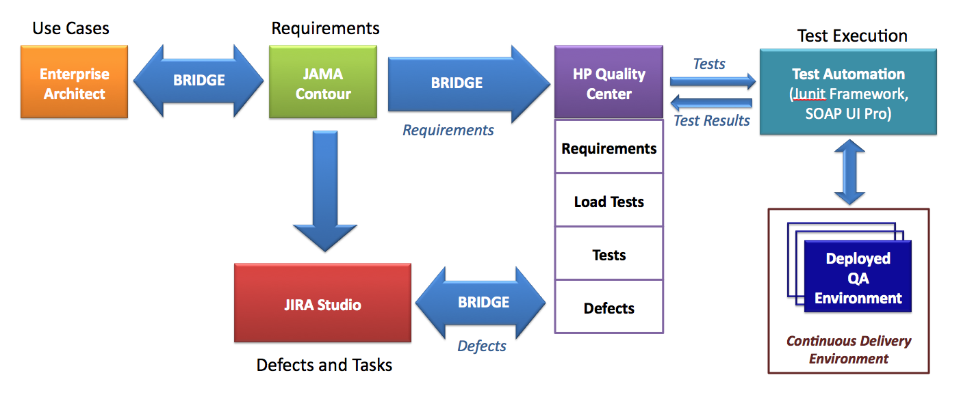

Automated Testing
- Developer unit tests will be created in jUnit 4.8.
- HP Quality Center will be used to plan, record and report test case results.
- SoapUI Pro will be used as the test submission tool.

Requirements Traceability
- Requirements traceability will be used throughout the analysis-design-development-testing process. QA plans will use the JAMA Contour tool to track unique identification of requirements from the analysis team through to QA verification of each requirement in the completed component. Contour will be linked to:
♦ the Enterprise Architect tool used by the Analysis and Architecture teams, and
♦ the HP Quality Center tool used by the QA team.
- The development team must show that all of the requirements are captured in the PIM.
- QA must show that all requirements in the PIM have been tested.

Metrics and Defect Tracking
- JIRA is the central caBIG® Clinical Information Suite location for all defects. JIRA Studio is the hosted software development suite used by the project to support the Agile development process.
- HP Quality Center (QC) is used for test case management, which includes a defect tracking capability as well. See the example screenshot below. Defects will be entered by QA into the QC defect tracker, and a synchronizer called JIRA Bridge will be used to create corresponding JIRA issues that are synchronized both ways as updates are made.
- Monitoring Continuous Integration environment code quality: The Continuous Integration environment will use Sonar, an aggregate code analysis tool, to provide dashboard reporting on source code quality. Sonar reporting for the project can be found at http://ci.caBIG.net:48080/sonar/

Example of HP QC Test Tracking

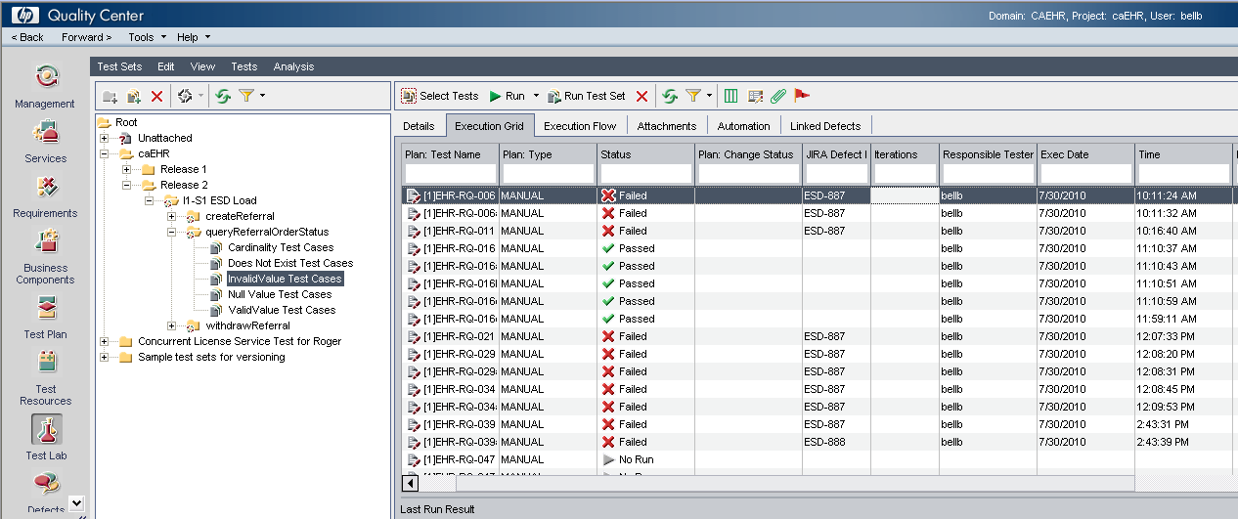

Appendix A – Example HP QC Component Test Report

